MHEP Registration Instructions

Welcome to the new registration system for the Mechanic Helper Education Program (MHEP) noncredit trainings for continuing education and professional development. Below you will find instructions on how to create a Learner profile (new users), find and register for a training, and access your training. If you have any questions or issues navigating the new system please email the MHEP program manager, Wade Weiss by clicking above or at: wweiss6@alaska.edu

Table of Contents:
- Setting up a new learner profile (new users)
- Dashboard
- Change Password and Account Details
- Register for Training

Setting up a NEW Learner profile:

To set-up a new learner profile, go to the MHEP course registration page. Learners will need to set-up a new user profile to register for trainings in the new system.

1- First Name - Enter your First Name
2- Last Name - Enter your Last Name
3- Email - Enter your email. For first time users, use your personal email address for easiest management.
4- Affiliation - This should be auto-filled with the correct settings if you followed the link above. If for some reason this field is not filled, Select University of Alaska > University of Alaska Anchorage > Community & Technical College >

5- Phone Number - Enter a phone number for your record. Please enter the number without any punctuation or spaces (ex. (555) 555-5555 would be entered as 5555555555).
6- Date of Birth - If this option appears please enter your birthdate. This information will be used for security purposes to verify your identity for your account. If this field is not present, you will still be able to create a learner profile.
7- Register Button – Click this when the form is complete to create your account.

Once you register, you will receive an email containing your Username (email) and a temporary password to access your account. The email also contains a link to a login page.

We will review how to change your password in a later section.

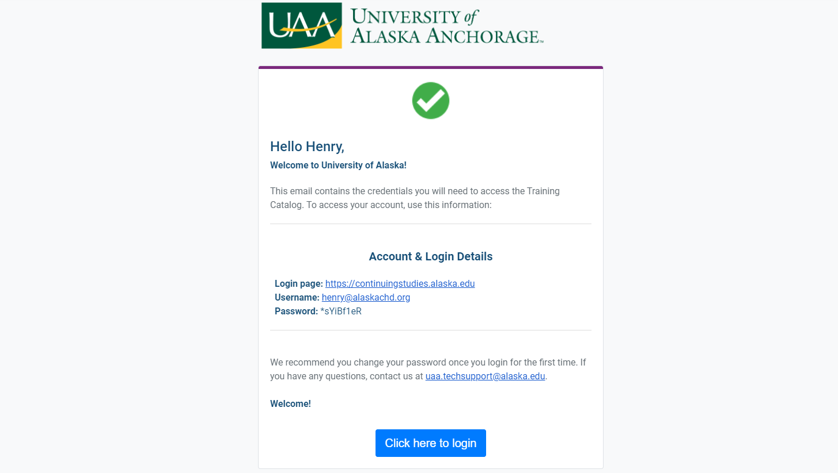

Dashboard:
Once your profile is created, you will be able to login and view your dashboard. The dashboard will give you different options to manage your trainings, records and payments. Here we will focus on changing your password, and finding and enrolling in trainings.

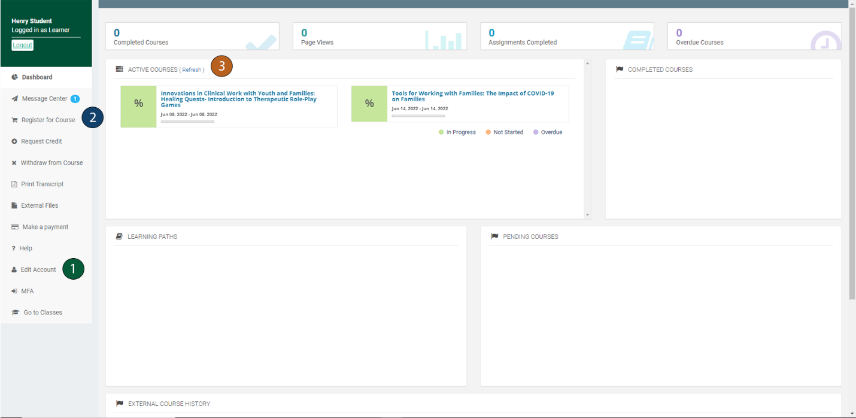

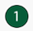 Edit Account - Clicking here will allow you to edit your profile information. You will also change your temporary password here created upon registration. (skip to Change Password Section)

Register for a Course/Training - This will link you to the catalog of all courses available allowing you to browse trainings being offered and to register for trainings. (skip to Register for Training Section)

Active Courses - This area of the dashboard will contain all courses you have registered for.

Change Password and Account Details:
To change your password from the one that was generated when you registered:
- Click on the Edit Account option from the menu on the left-hand side of the Dashboard. This will open the Edit Account page.

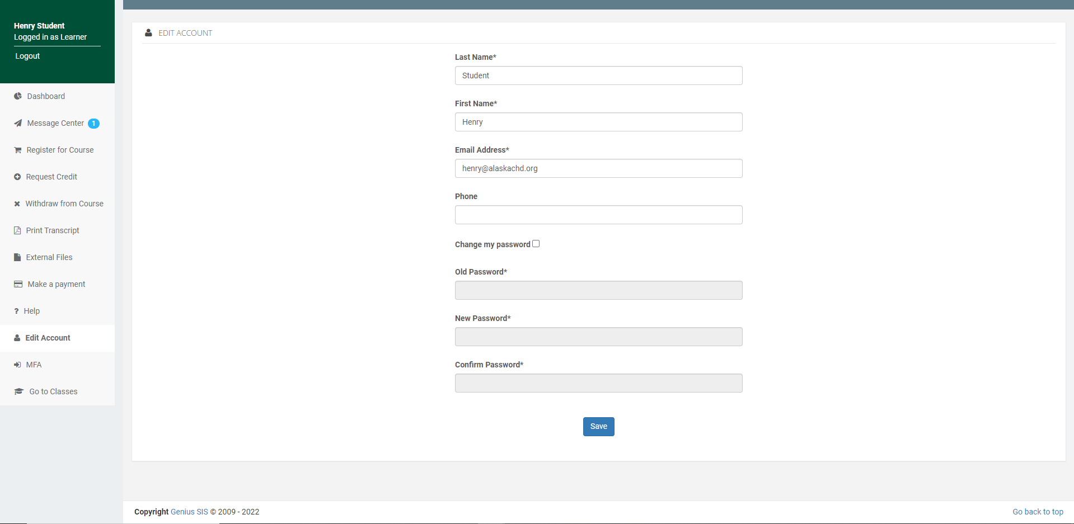

- To change your password, check the Change my Password box.
- Enter your old password, which can be found in your registration email.
- Enter your new password and confirm it.
- Click Save to set your new password.

To change other account details such as email address or last name:

1. Click on the Edit Account option from the menu on the left-hand side of the Dashboard. This will open the Edit Account page.
2. To change your email address or last name, type in the box the new email address.
3. Click Save to set your new email address.

Register for Training:
To access the catalog of available trainings:
- Click the Register for Course in the menu on the left of the Dashboard. This opens the Course Catalog.

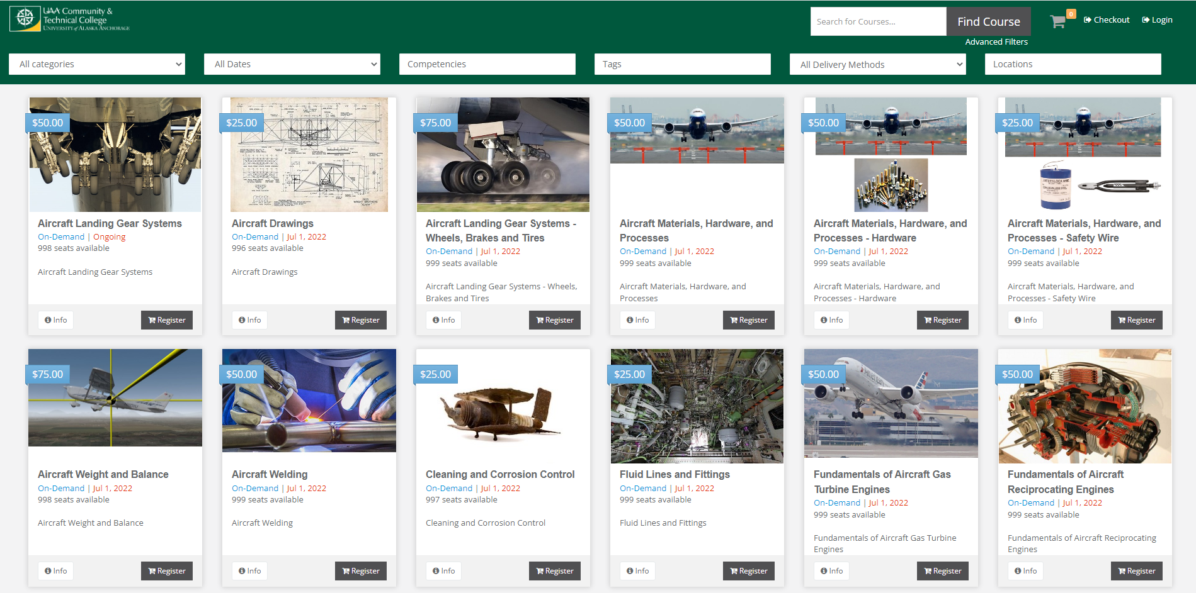

- To view a description of the course, click the Info button in the bottom left of the course you are interested in attending.
- If you would like to enroll in the course, click the Register button in the bottom right. You can select multiple courses to register for at once by clicking the Register button on multiple courses. These will be saved in your Cart, even if you log out of the system and return at a later time.
- When you are ready to proceed, you can click the Checkout in the top right of the screen. You can review the trainings you have selected and remove any items if needed. This is also when you would apply any Coupon codes provided for free courses and select your payment method.

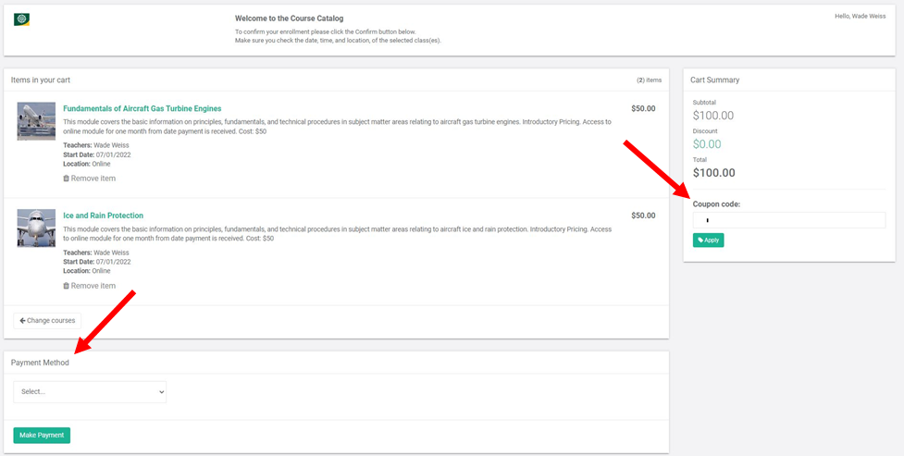

- Once you have completed making the required payment, your courses will now be visible in the Active Trainings section of the Dashboard.

